Why we’re doing this.  Summarise the reason for the informer. | We are launching a month-long campaign to engage the Kelston, New-Lynn and Glen Eden communities on our proposal for a new cycling and walking network that stretches for around 8km and will link with public transport and other cycling and walking routes like Te Whau pathway and the New Lynn-Avondale shared path.  Generally, any time we go out to our communities about cycling infrastructure there is some degree of contention – particularly in regard to cost, disruption and relevance/rationale. We are sharing this with you to help you navigate any questions or comments you may receive from your stakeholders and customers.  Our goal is to build awareness and encourage community feedback while addressing concerns by utilising data, relevant communications channels and existing community connections that have been established by pre-consultation activities and the Streets for People activations.  As such, our engagement activity for the campaign aims to:  - Inform and meaningfully engage the Kelston and New-Lynn communities so we receive valuable and actionable feedback  - Continue to work closely with key stakeholders (relationships that were established early in the project) to elicit further input from their networks and identify any key issues that need to be addressed ahead of the public drop-in sessions  - Maximise the reach of the engagement process to include as many people as possible in the project area  - Identify and work with key community champions for this project to deliver a campaign that increases the appetite, capabilities and community capacity for cycling and walking in local neighbourhoods  - Ensure key audiences are aware of the rationale for the route selection as well as specific safety improvements, tree removal, re-allocation of road-side space or any other changes to the streetscape that may have reputational impacts  - Close out the consultation by ‘closing the loop’ and communicating the outcomes and changes (if applicable) to stakeholders to facilitate greater understanding and buy-in.
What we’re doing  Description of project and background | We are creating safer walking and cycling connections in the Kelston, New Lynn and Glen Eden area. The proposed new connections for these communities include the following:  - shared paths in the berm / footpath area  - on-road cycle lanes (protected with a separator)  - improved crossing facilities near schools and local shops, including changes to the road layout at St Leonards Road, Archlynn Road and Archibald Road  - improvements to the traffic calming measures in quiet streets.  The key benefits we will deliver for these communities:  1. Improved safety and enhanced wellbeing for people on bikes and people on foot  2. Better connections with public transport hubs, facilitating seamless multi-modal travel and reducing reliance on cars, as well as linking Kelston and New Lynn with other parts of Auckland, opening up opportunities to reach even more destinations.  3. Using what’s already there by making the most of existing footpath space and temporary infrastructure.  To deliver these benefits we recognise the importance of engaging with the Kelston-New Lynn community to ensure the proposed design elements aligns with their needs and preferences. By seeking input through consultation, we aim to gather valuable local knowledge and insights – particularly in regard to local considerations we may have missed, as well as identify potential issues and address concerns to refine the designs as the project progresses.  Specifically, we are asking for:  - Input on safety elements across the network, especially around the shared streets of New Lynn central area.  - Insight into anything we may have missed and local knowledge about issues we may have overlooked when it comes to treatments like: -  - Wayfinding signage – for what and where?  - New secure bike parking locations  - Mobility and accessibility: Ensure everyone including older people and people with diverse mobility needs has what they need to move around with ease, for example ramps for wheelchairs and prams, mobility scooters, tactile pavers  - Other: If a stakeholder identifies a conflict with the way they currently use the road / footpath space at certain location we are keen to hear their concerns. Where possible and appropriate, we will try to mitigate the issue at the next design phase, for example a cycle lane by-pass to retain parking in front of a dairy, or commercial issues with loading and servicing.  Non-negotiables  - We are not asking stakeholders and the community if they support or don’t support the proposed new walking and cycling network.  - We are not seeking feedback on new suggestions/alternatives to the proposed routes.  - We are not seeking support for the type of crossings and the locations at which we are proposing these safety interventions.
Key messages | - Thriving cities have a network of transport choices that work together to provide stress-free, reliable and affordable journeys for everyone. It requires seamless public transport, safe connections to walk, bike and drive, as well as efficient, well-maintained routes for driving and moving goods around. This connects people to jobs, education, services and cultural and social activities. It creates and supports investment and economic growth as well as safe streets and neighbourhoods.  - We recognise that a thriving city = flourishing neighbourhoods. We are working to deliver more local transport choices underpinned by a safe cycling and walking network across Tāmaki Makaurau / Auckland, and with 3.25 million cycle movements recorded across our 26 count sites over the last year to June 2024, we are now filling some of the gaps in our communities out west.  - The proposed walking and cycling network for Kelston, New Lynn and Glen Eden will stretch for around 8kms linking with public transport and other cycling and walking routes like Te Whau pathway and the New Lynn-Avondale shared path.  - Our proposal for this project includes safe and easy-to-use walking and cycling connections that gets you to your school, your sports field, your workplace, your local shops and all the places you love in a way that is good for you, your whānau and the environment.  - This network will connect the busy New Lynn centre that has on an average nearly 3,000 people moving through it every day, with nearby residential areas and schools in Kelston serving approximately 3,500 tamariki.  - These improvements will encourage more people to cycle and walk in New Lynn, Glen Eden and between Kelston schools. Our recent travel behaviour survey shows 69% of the community will be encouraged to take more trips by a bicycle or scooter if safe cycling and walking infrastructure is available.  - Our plans use quieter streets and off-road paths to minimise disruption and reduce cost. We will also draw from the successful Streets for People Onewherowhereo Kelston trial to look at how we can retain the benefits of the temporary infrastructure in designing permanent infrastructure.  - We know that infrastructure alone is not enough to get communities in West Auckland walking and cycling, and ultimately, flourishing. We’re making it easier for people to identify safe cycling routes and setting up bike hubs in communities to make it easier and cheaper for people to fix and maintain their bikes. We’re also offering bike skills courses for those who can’t ride or for those wanting to brush up and get more confident on a bike.  - While the plans we are proposing are quite detailed, we genuinely want to hear from you with your local knowledge to ensure we deliver something that will support seamless and safe travel choices in your community.
Who needs to know | - Key stakeholders – Whau and Waitākere Ranges local board members, Te Kawerau a Maki, New Lynn Business Association, Glen Eden Residents and Ratepayers Association, local schools, businesses and community groups  - Kelston, New Lynn and Glen Eden communities affected by the proposed changes.  - Commuters and regular visitors to the New Lynn transport centre, and Fruitvale train station.
Timelines (subject to finishing the business case and funding approval)  Key dates | - 26 August 2024 – 23 September 2024: Public consultation period  - Postcard delivery and social media campaign starting on 26 August 2024  - Community info sessions:  8 September Community drop-in session 1 (Venue: Kelston Community Hub, any time between 4:00 – 6:00 pm)  12 September Community drop-in session 2 (Venue: New Lynn Library, any time between 12:00 – 2:00 pm)  14 September Community drop-in session 3 (Venue: Eco Matters bike hub, New Lynn, any time between 10:00 am – 12:00 pm)  17 September Community drop-in session 4 (Venue: Glen Eden Library, any time between 5:00 – 7:00 pm)
Communication Channels  What, where, how | - 26,000 postcards delivered to Kelston, New Lynn, Glen Eden and Glendene households and businesses.  - Postcards and display boards at local shops, libraries, community centres and schools in Kelston, New Lynn and Glen Eden.  - Social media geotargeted ads on Facebook and Instagram.  - Display boards at the New Lynn, Fruitvale and Glen Eden train stations.  - Online and offline marketing channels: Monthly cycling and walking newsletter, project information in the Viva magazine for the winter cycling campaign.  - Community info sessions – dates and time mentioned above.  - In-person engagement with schools to get feedback from their students as the proposed changes impact them significantly.
The Bigger Picture: Our Purpose & Principles  How does this relate to Tiaki purpose/principles? | Ka tiaki mātou i te hunga katoa ka eke waka i Tāmaki Makaurau.  We tiaki all who use transport in Tāmaki Makaurau  ☒ Listen & respond to needs of our customers & communities  ☐ Partner with Māori to deliver a transport system that improves outcomes for all  ☒ Put people and places at the heart of how we design and deliver our transport system  ☐ Lead & Partner – bring all players together to take a whole system view
Our ambitions | ☒ Safe journeys for everyone  ☒ More people choose to walk, cycle & use public transport  ☒ A better experience on our existing network  ☐ Seamless & reliable public transport  ☐ A resilient & sustainable transport system
More Information | For more information contact: ATEngagement@at.govt.nz  Webpage: https://haveyoursay.at.govt.nz/kelston-newlynn
Creative  Including images | Social media tiles – infeed and stories  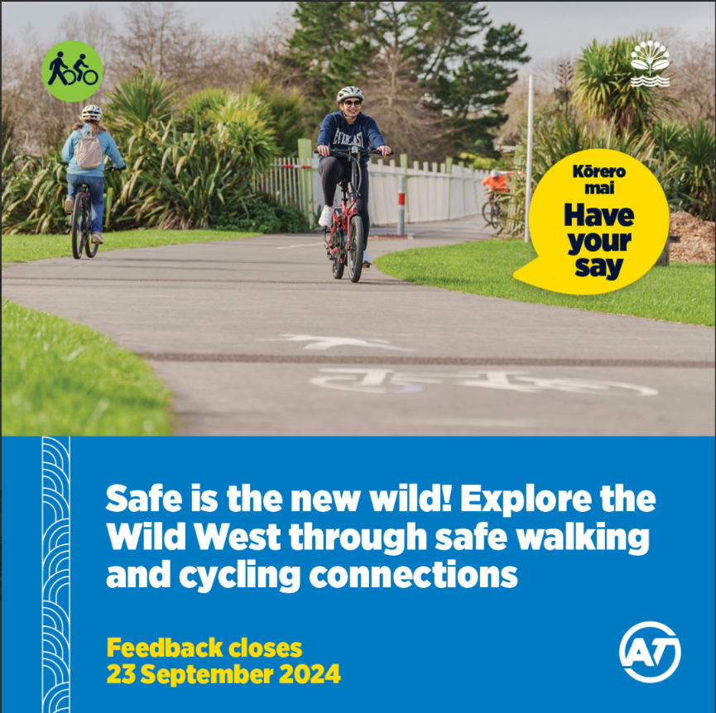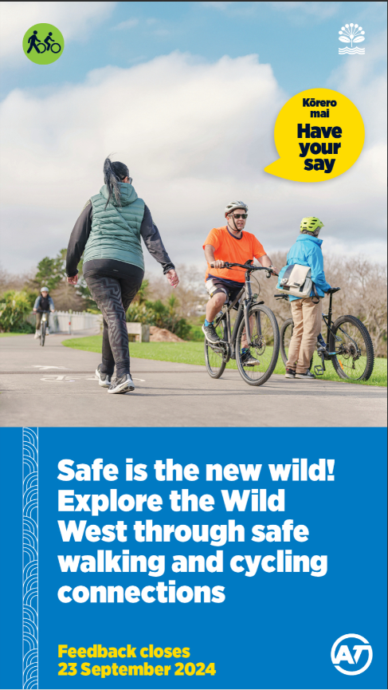  A5 postcard flyer (this is also being translated into te reo Māori, Samoan and Tongan)  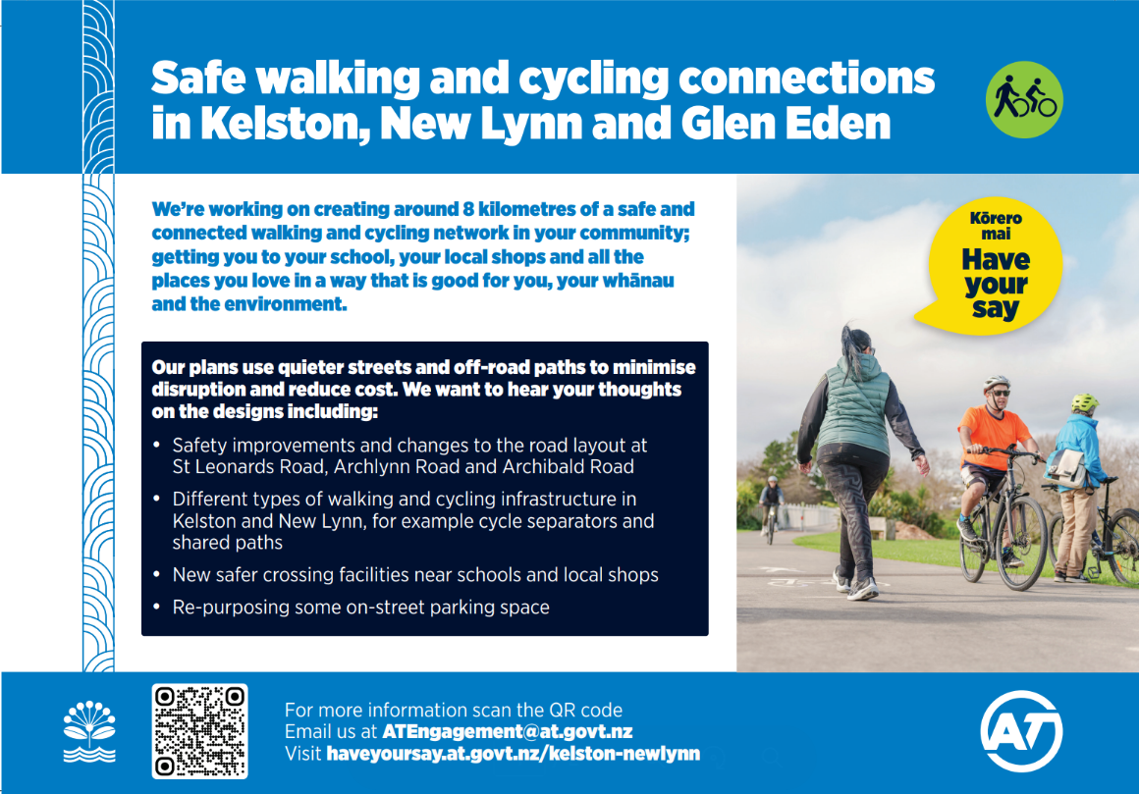  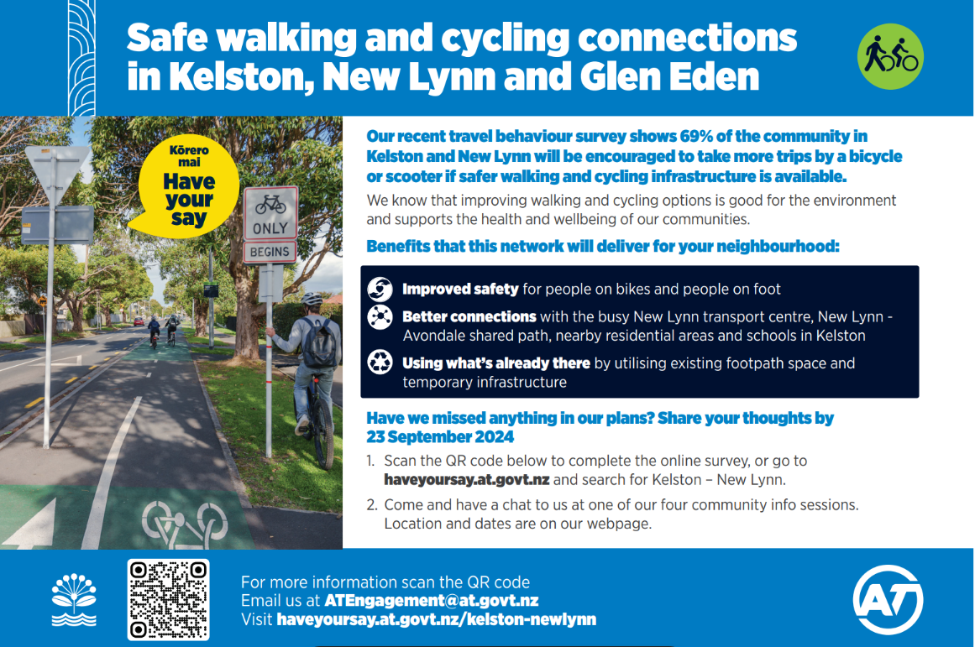  Display poster  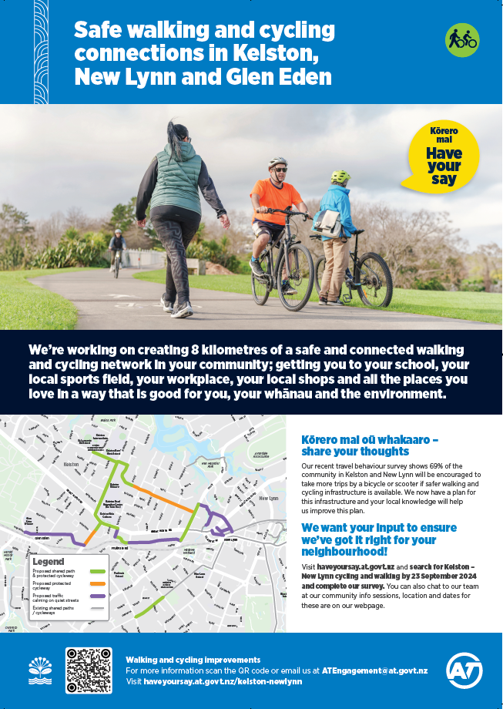  Network maps  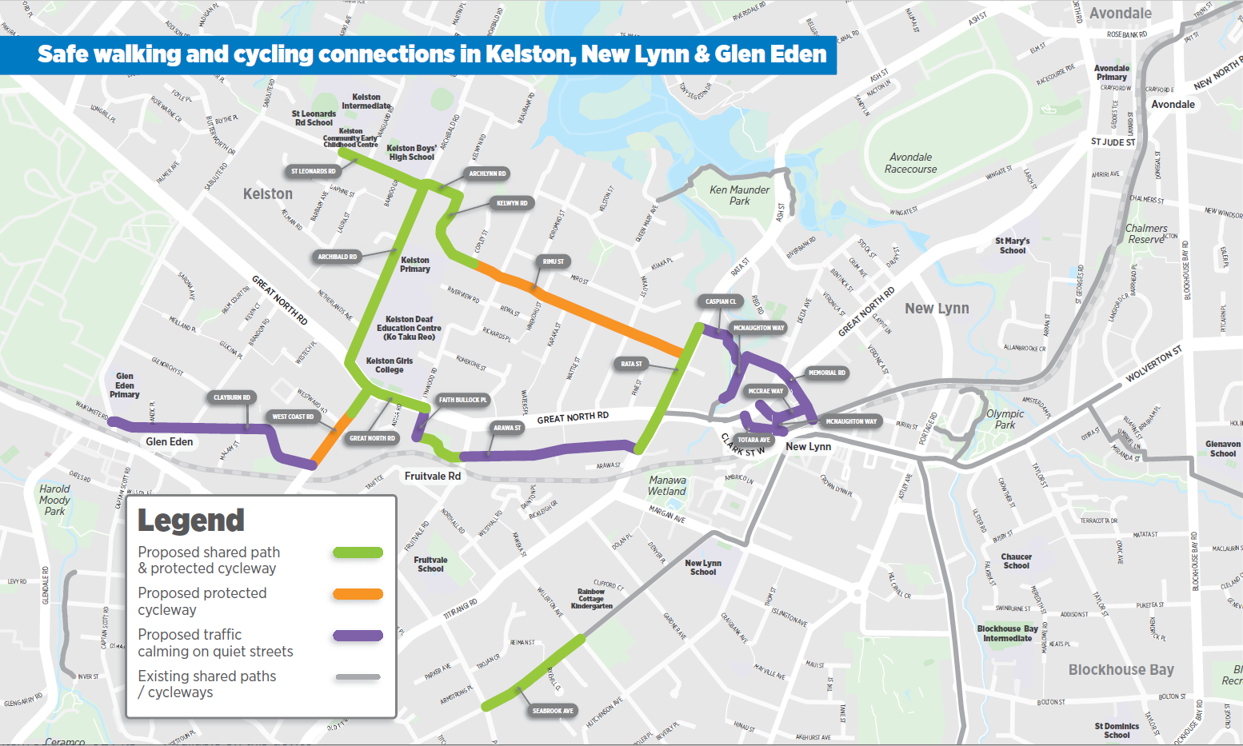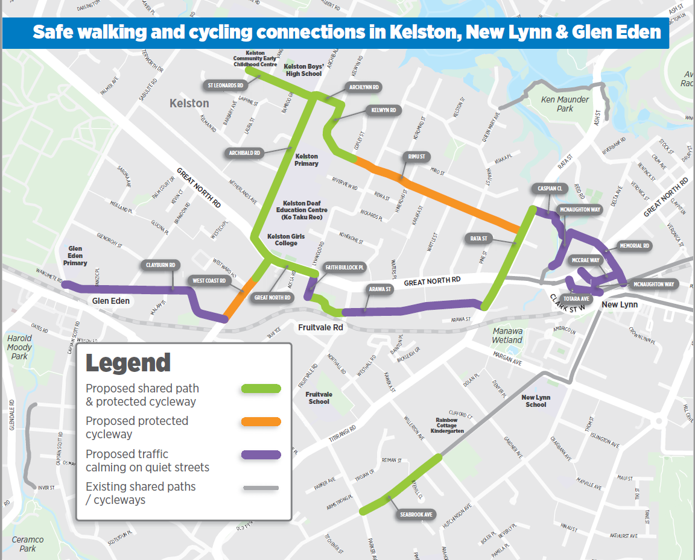  EDM banners  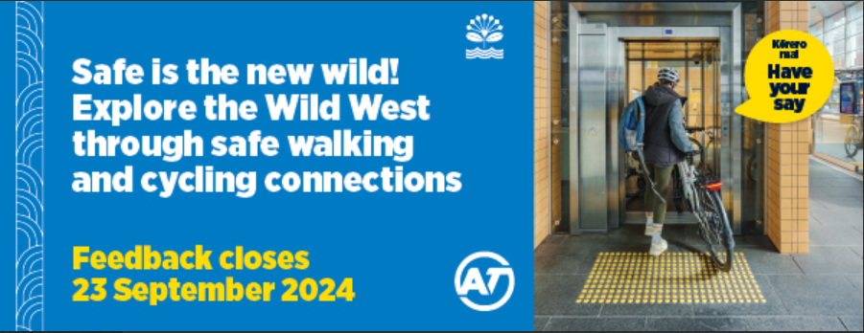  Network video educational tool that has the purpose of explaining how we developed the proposed network: https://youtu.be/COXhBgRKEoI

